Mr. Boronyak
Physical Education
Name:

Class: __________

March is Muscle Month. Do you know your Muscles?

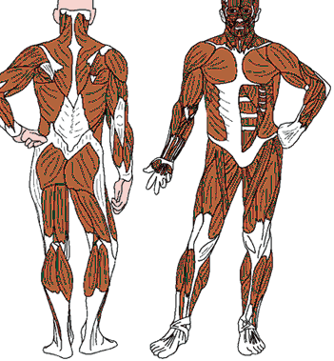  Rear Muscles  Gluteus  Deltoids  Hamstrings  Traps (trapezius)  Triceps  Calves (gastrocnemius)  Lats (latissimus dorsi) | Front Muscles  Quads (quadriceps)  Obliques  Deltoids  Abs (abdominals)  Biceps  Pecs (pectoralis)

Instructions
Draw an arrow from the name of the muscle to the correct place on the picture. Turn in during the month of March for bonus points!

